**Advanced Diploma of Information Technology**

**ICTNWK541 Assessment**

**Assessment Task 2: Project Portfolio**

**Manuel Sergio Perez Espitia**

**March 20th 2025, Melbourne, Victoria, Australia**

**ABC Enterprises WAN Expansion**

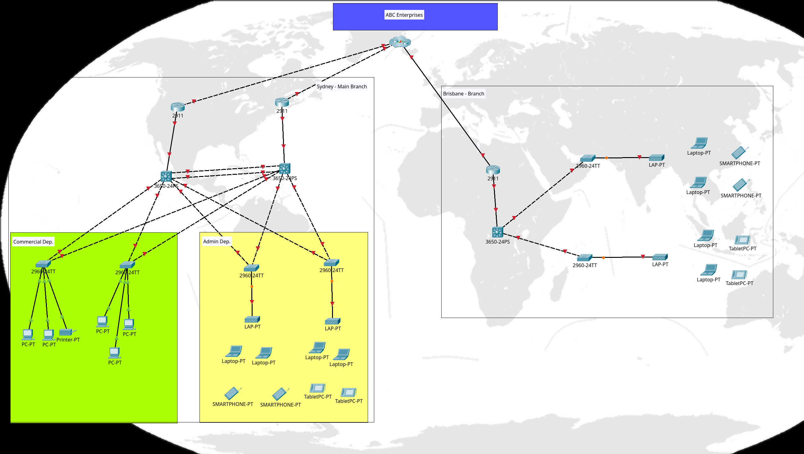

ABC Enterprises is a growing company with headquarters in Melbourne and two branch offices in Sydney and Brisbane. The company currently operates with an outdated network infrastructure that lacks secure, reliable WAN connectivity between sites. The IT department has been tasked with designing, implementing, and securing a new WAN infrastructure that ensures:

* Secure VPN connectivity between all sites.
* Optimised bandwidth usage with reliable routing protocols.
* Proper IPv6 deployment for future scalability.
* Enhanced security mechanisms including firewall rules and access control lists (ACLs).
* Troubleshooting and monitoring tools to detect and rectify network issues efficiently.

As part of the project, you will act as a network engineer responsible for implementing the required WAN connectivity for ABC Enterprises.

# Simulation Software & Tools:

Software installed to develop this protect.

* Cisco Packet Tracer 8.2.2
* Ubuntu 24.04 LTS
* Wireshark 4.2.2

# Network Design Review & Planning

## Network Details

### Topology and type

* Sydney Branch: LAN - Dual-Star
* Brisbane Branch: LAN - Star

### Network Nodes

|  |  |  |
| --- | --- | --- |
| **Type** | **Quantity** | **Branch** |
| PC | n | Sydney |
| Laptop | n | Sydney |
| Smartphone | n | Sydney |
| Tablet | n | Sydney |
| Printer | 1 | Sydney |
| Switch | 4 | Sydney |
| Switch Multi-layer | 2 | Sydney |
| W Access Point | 2 | Sydney |
| Router | 2 | Sydney |
| Laptop | n | Brisbane |
| Smartphone | n | Brisbane |
| Tablet | n | Brisbane |
| Switch | 2 | Brisbane |
| W Access Point | 2 | Brisbane |
| Router | 1 | Brisbane |
| Cloud Cluster | 1 | ABC Enterprises |

## Legal And Security Protocol

## Installation Plan

# Wan Configuration

## General Implementations

1. Rename all devices:   
   sw (switches), rt (souters), ap (Wireless Access Points), ss ( Servers)
2. Connect Firewalls and Switches multi-layer
3. Install 2 servers to: DHCP, DNS and (1) its own switch
4. Connect server’s switch and both switch multi-layer
5. Implement Secure Access by SSH
6. Additional Protocols: DHCPv6, IPV6

## Implement Firewalls

## WAN Protocols: PPP, VPN Site-To-Site, ADSL

## Additional Protocols: DHCPv6, IPV6

## Implement Network Topology

# Network Security Implementation

## Apply Access Control Lists (ACLS)

## Secure Access By SSH

### Switch 1

enable

configure terminal

service password-encryption

username administrator password cisco

ip domain-name netacad.pka

hostname sw1

crypto key generate rsa general-keys modulus 1024

ip ssh version 2

line vty 0 15

transport input ssh

login local

exit

do wr

#### test: ssh -l admin <ip_switch>

### Switch 2

enable

configure terminal

service password-encryption

username administrator password cisco

ip domain-name netacad.pka

hostname sw2

crypto key generate rsa general-keys modulus 1024

ip ssh version 2

line vty 0 15

transport input ssh

login local

exit

do wr

exit

exit

#### test: ssh -l admin <ip_switch>

### Switch 3

enable

configure terminal

service password-encryption

username administrator password cisco

ip domain-name netacad.pka

hostname sw3

crypto key generate rsa general-keys modulus 1024

ip ssh version 2

line vty 0 15

transport input ssh

login local

exit

do wr

exit

exit

#### test: ssh -l admin <ip_switch>

### Switch 4

enable

configure terminal

service password-encryption

username administrator password cisco

ip domain-name netacad.pka

hostname sw4

crypto key generate rsa general-keys modulus 1024

ip ssh version 2

line vty 0 15

transport input ssh

login local

exit

do wr

exit

exit

#### test: ssh -l admin <ip_switch>

### Switch 5

enable

configure terminal

service password-encryption

username administrator password cisco

ip domain-name netacad.pka

hostname sw5

crypto key generate rsa general-keys modulus 1024

ip ssh version 2

line vty 0 15

transport input ssh

login local

exit

do wr

exit

exit

#### test: ssh -l admin <ip_switch>

### Multi-layer Switch 1

Before configure, install AC-POWER-SUPPLY module.

enable

configure terminal

service password-encryption

username administrator password cisco

ip domain-name netacad.pka

hostname swm1

crypto key generate rsa general-keys modulus 1024

ip ssh version 2

line vty 0 15

transport input ssh

login local

exit

do wr

exit

exit

#### test: ssh -l admin <ip_switch>

### Multi-layer Switch 2

Before configure, install AC-POWER-SUPPLY module.

enable

configure terminal

service password-encryption

username administrator password cisco

ip domain-name netacad.pka

hostname swm2

crypto key generate rsa general-keys modulus 1024

ip ssh version 2

line vty 0 15

transport input ssh

login local

exit

do wr

exit

exit

#### test: ssh -l admin <ip_switch>

# Troubleshooting & Testing:

## Testing WAN Connectivity.